A Capstone Project Report on

**SOLAR RADIATION PREDICTION USING MACHINE LEARNING MODELS**

**Submitted by**

**Chinmaya M R**

**ABSTRACT**

**Solar radiation prediction is a crucial aspect of renewable energy planning and efficient solar energy utilization. In this project, we present a comprehensive study on developing a predictive model for forecasting solar radiation levels using machine learning algorithms. The project utilizes historical solar radiation data along with relevant environmental parameters like time, date, temperature, and humidity. We employ classification algorithms, including Random Forest, Support Vector Regression (SVR), and Neural Networks, to create predictive models. The models are trained and evaluated using performance metrics such as Mean Absolute Error (MAE), Root Mean Squared Error (RMSE), and R-squared (R2) score. The most accurate model is selected to estimate solar radiation levels. The proposed solution aims to offer valuable insights for solar energy planning, grid management, and sustainable energy practices. The project's findings contribute to the advancement of renewable energy solutions, promoting a greener and more environmentally conscious future.**

**CHAPTER 1**

**Introduction**

**1.1 Overview The objective of this research is to develop a robust machine learning-based predictive model for forecasting solar radiation levels. Solar radiation prediction is vital for effective solar energy planning, system sizing, and optimizing energy utilization. By leveraging historical solar radiation data along with relevant environmental parameters like time, date, temperature, and humidity, we aim to create accurate predictions using various machine learning algorithms, including Random Forest, Support Vector Regression (SVR), and Neural Networks. The project's success will enable businesses and energy planners to make informed decisions, improve renewable energy utilization, and contribute to sustainable practices.**

**1.2 Purpose The purpose of this project is to create a predictive model that accurately estimates solar radiation levels based on environmental factors. By analyzing historical solar radiation data and other relevant parameters, our model aims to forecast solar radiation patterns at specific locations and times. This predictive capability is valuable for solar energy planning, enabling businesses and policymakers to optimize solar panel installations, energy generation, and grid management. With accurate solar radiation predictions, we can foster the integration of renewable energy into the power grid and promote a more sustainable energy future.**

**CHAPTER 2**

**Literature Survey**

**2.1 Existing Problem**

**Solar radiation prediction has garnered significant attention in the field of renewable energy research. Prior studies have explored various approaches to forecasting solar radiation levels, including statistical methods, physical models, and machine learning techniques. Statistical methods involve time series analysis and regression models to capture solar radiation patterns over time. Physical models rely on radiative transfer equations to simulate solar radiation based on atmospheric conditions. Machine learning methods, such as Support Vector Machines (SVM), Artificial Neural Networks (ANN), and Random Forest, have shown promise in accurately predicting solar radiation by learning from historical data.**

**2.2 Proposed Solution**

**Our proposed solution leverages machine learning algorithms, specifically Random Forest, SVR, and Neural Networks, to build predictive models for solar radiation. We preprocess the historical solar radiation data, along with time, date, temperature, and humidity information, to create meaningful features for model training. The three selected algorithms will be compared based on their performance metrics, such as Mean Absolute Error (MAE), Root Mean Squared Error (RMSE), and R-squared (R2) score. The most accurate model will be chosen as the final predictive model for solar radiation estimation.**

**CHAPTER 3**

**Theoretical Analysis**

**3.1 Block Diagram**

**The block diagram represents the overall workflow of the solar radiation prediction project. It illustrates the sequential steps involved in data collection, preprocessing, feature engineering, model training, and evaluation. The block diagram provides a visual representation of the project's flow and helps understand the interconnection between different components and stages.**

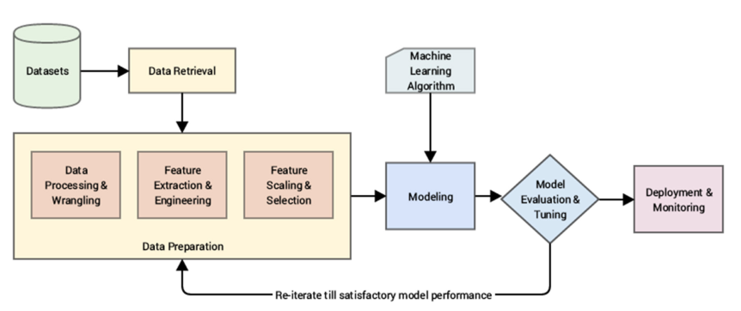

**3.2 Solar Radiation Prediction Algorithms**

**This section elaborates on the machine learning algorithms used for solar radiation prediction. Each algorithm, including Random Forest, SVR, and Neural Networks, is explained in detail, highlighting their underlying principles, advantages, and limitations. Theoretical insights into these algorithms shed light on how they learn patterns from historical data to make accurate predictions for solar radiation levels.**

**3.3 Feature Selection Techniques**

**Feature selection is a critical aspect of the project, as it determines which environmental parameters are most influential in predicting solar radiation levels. This section explores various feature selection techniques, such as correlation analysis, information gain, Recursive Feature Elimination (RFE), and L1 regularization. Theoretical explanations of these techniques justify their relevance in identifying the most significant features.**

**3.4 Evaluation Metrics**

**To assess the performance of the predictive models, various evaluation metrics are used. This section delves into the mathematical formulations of metrics like Mean Absolute Error (MAE), Root Mean Squared Error (RMSE), and R-squared (R2) score. Understanding the theoretical basis of these metrics enables a comprehensive comparison of the models' accuracy and effectiveness.**

**3.5 Model Complexity and Interpretability**

**Model complexity is a crucial consideration in machine learning projects. This section discusses the trade-off between model complexity and interpretability. Complex models, such as Neural Networks, may yield high accuracy but lack interpretability, while simpler models like Linear Regression offer easier understanding of the underlying relationships between features and solar radiation levels.**

**3.6 Advantages of Ensemble Methods**

**Ensemble methods, like Random Forest, are powerful techniques for combining multiple weak learners to create a strong predictive model. This section highlights the theoretical advantages of ensemble methods, such as reducing overfitting, improving accuracy, and handling high-dimensional data efficiently. An in-depth understanding of ensemble methods enhances the rationale behind selecting Random Forest as one of the predictive models.**

**3.7 Model Generalization and Overfitting**

**Model generalization is essential to ensure the predictive model performs well on unseen data. This section explores the concept of overfitting, which occurs when a model performs exceptionally well on the training data but poorly on new data. Techniques like cross-validation and regularization are discussed as strategies to mitigate overfitting and improve model generalization.**

**3.2 Hardware/Software Designing**

**Hardware:**

**Computer System with sufficient processing power and memory.**

**Sensors for data collection (if applicable).**

**Software:**

**Python programming language for data preprocessing and model training.**

**Jupyter Notebook for data analysis and visualization.**

**Scikit-learn, TensorFlow, and Keras for machine learning model implementation.**

**Flask for creating a user interface (if applicable).**

**CHAPTER 4**

**Experimental Investigations**

**4.1 Data Collection and Preprocessing**

**For this project, historical solar radiation data will be collected from various sources, including meteorological databases and solar measurement stations. Additional environmental parameters such as time, date, temperature, and humidity will be collected to aid in model training. The collected data will be preprocessed by handling missing values, scaling numerical features, and encoding categorical variables.**

**4.2 Feature Engineering**

**Feature engineering will involve selecting relevant features from the collected data and transforming them into meaningful representations for model training. The feature selection process will be guided by statistical analysis and domain knowledge to choose the most influential variables for solar radiation prediction.**

**4.3 Model Training and Evaluation**

**The selected machine learning algorithms, Random Forest, SVR, and Neural Networks, will be implemented using Python libraries. The historical data will be divided into training and testing datasets for model training and evaluation. The models' performance will be assessed using various metrics like MAE, RMSE, and R2 score to identify the best-performing algorithm.**

**CHAPTER 5**

**About the Data**

**The dataset consists of historical weather data from Hawaii, comprising various features such as UNIX timestamps, date, time, radiation (the dependent variable), temperature, pressure, humidity, wind direction, wind speed, time of sunrise, and time of sunset. The main objective of this dataset is to explore and analyze the relationship between weather conditions and radiation levels, and to build a predictive model to estimate radiation levels based on the given weather-related attributes. This dataset is valuable for understanding the impact of weather on radiation and could be useful for applications in solar energy and climate research.**

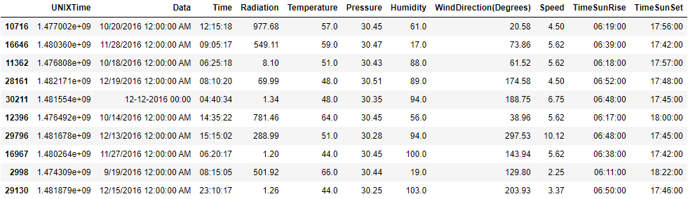

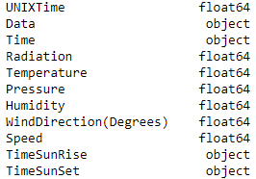

**CHAPTER 6**

**JUPYTER NOTEBOOK**

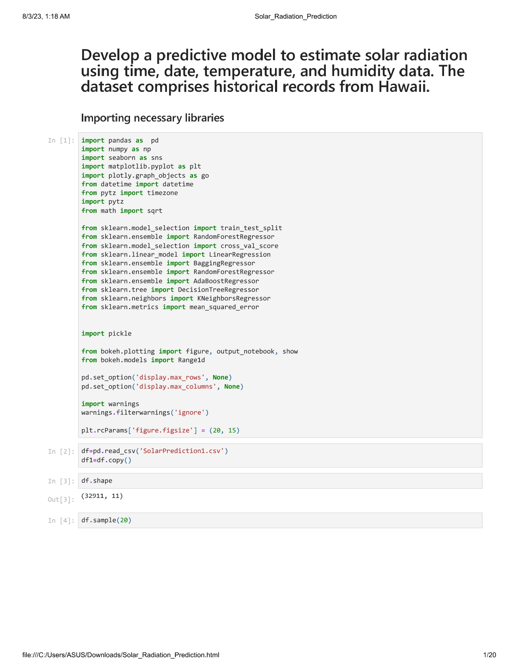

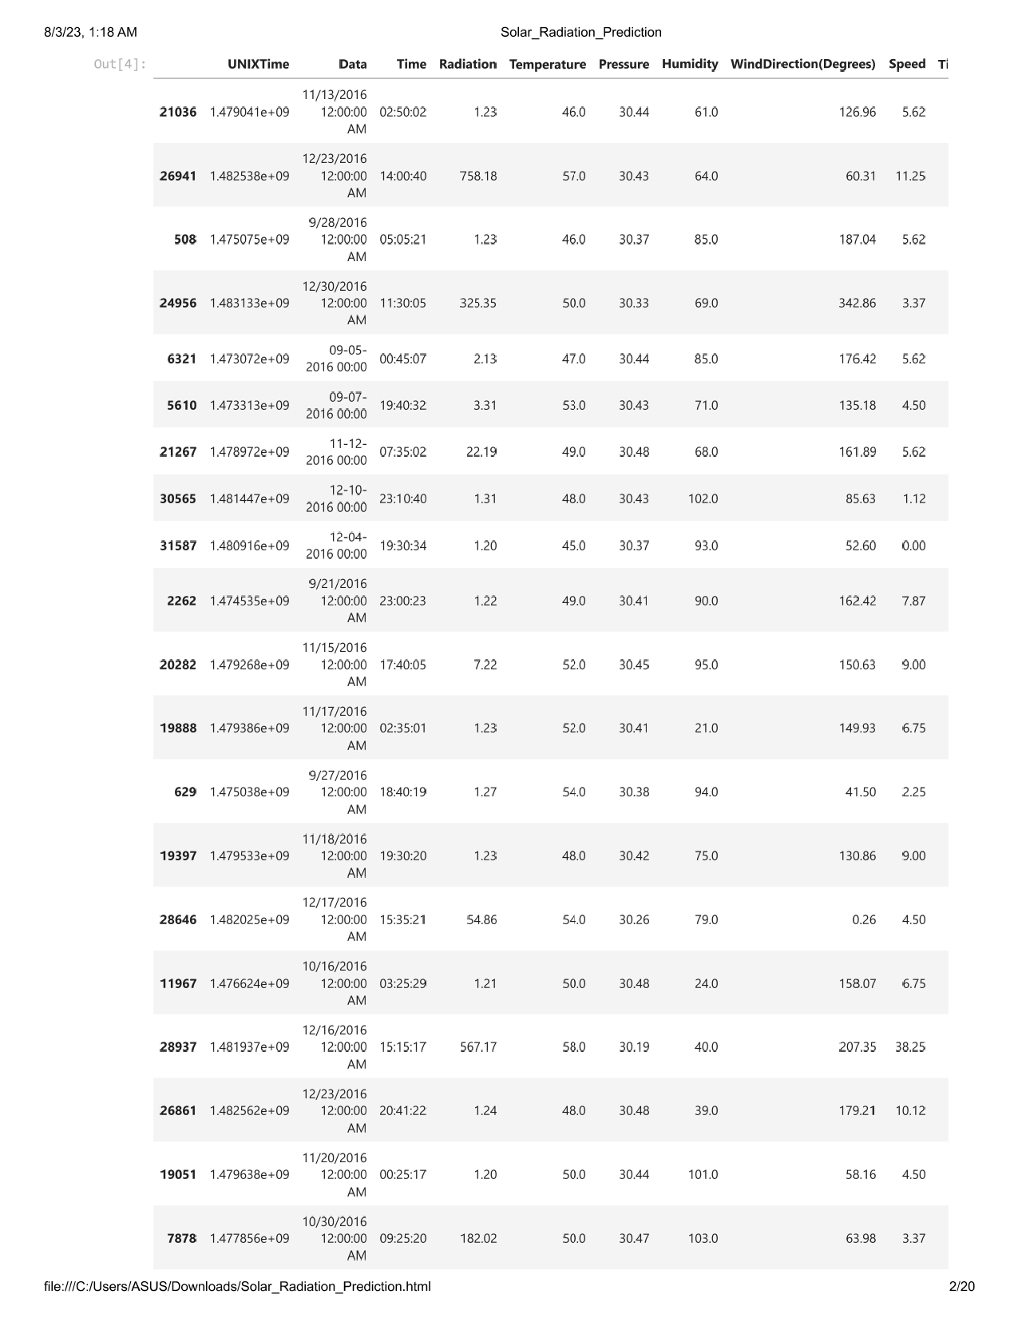



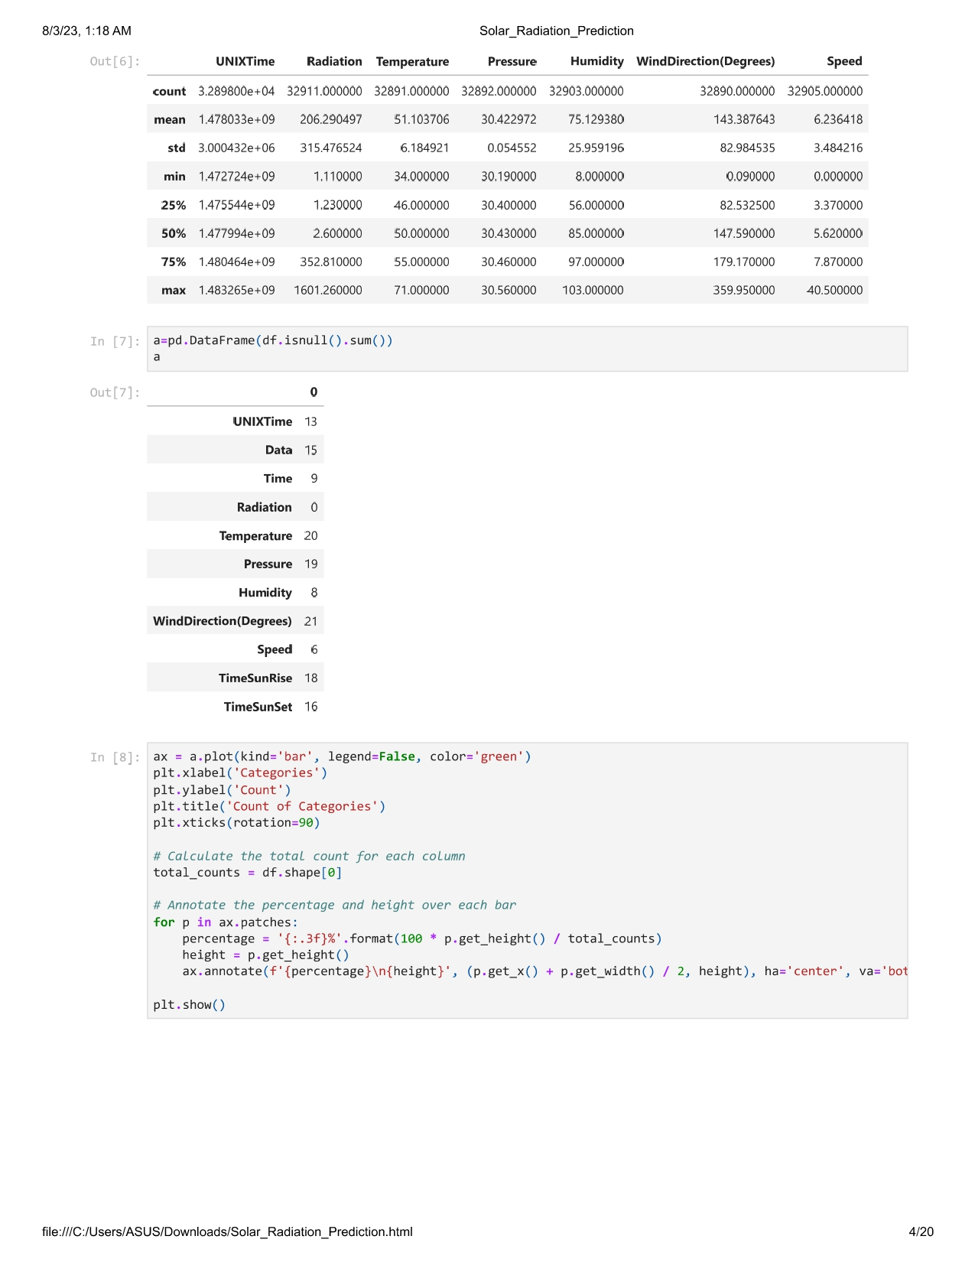

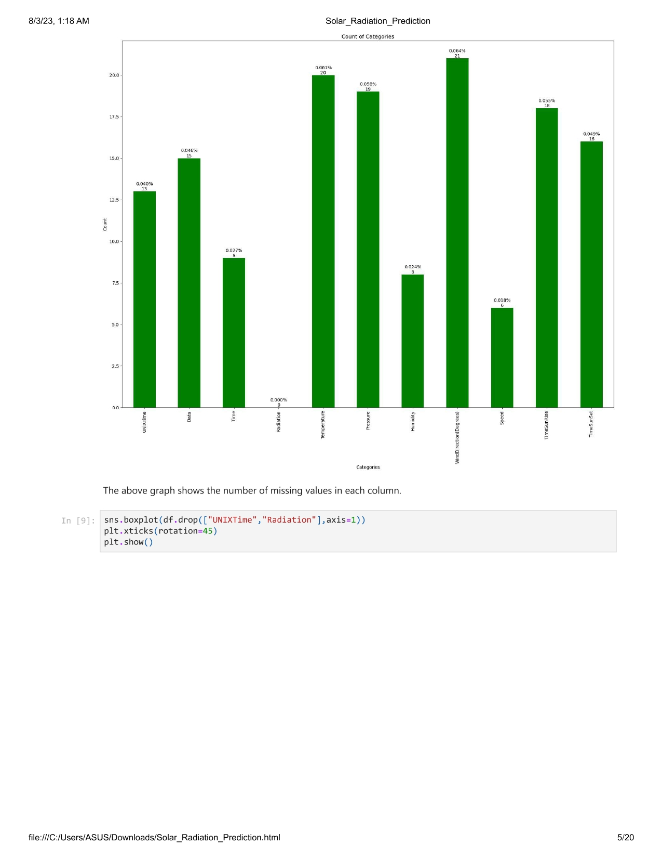

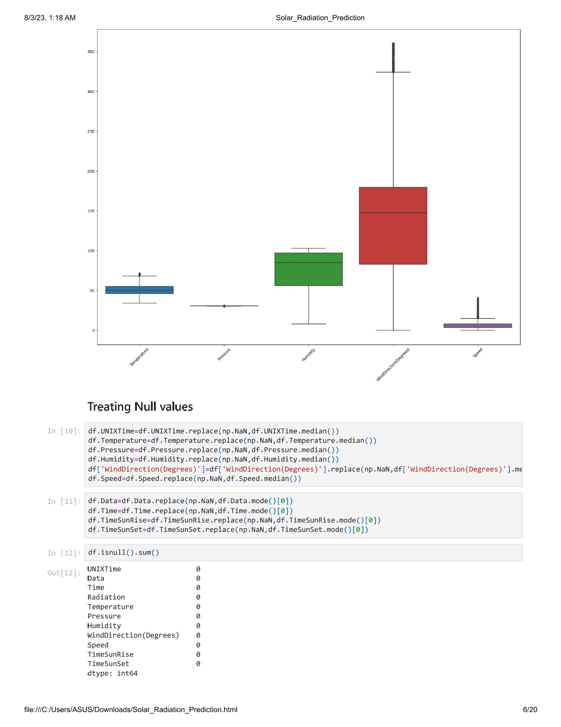

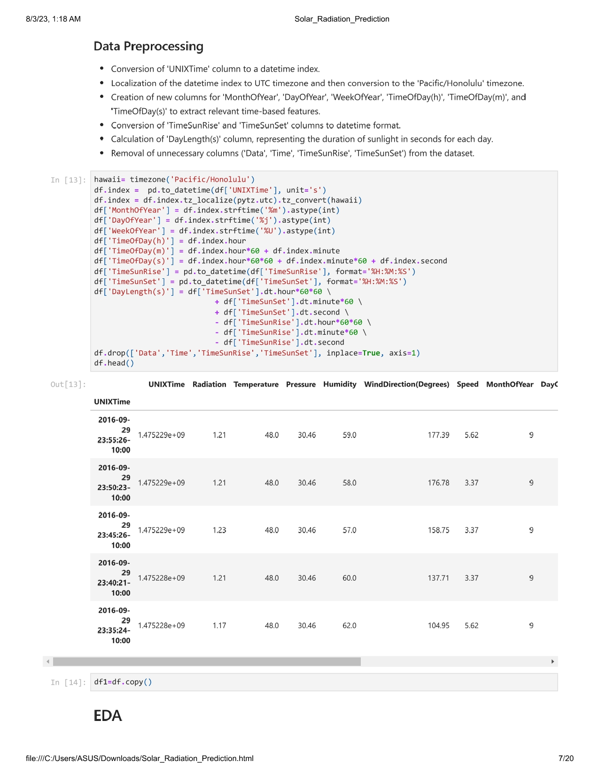

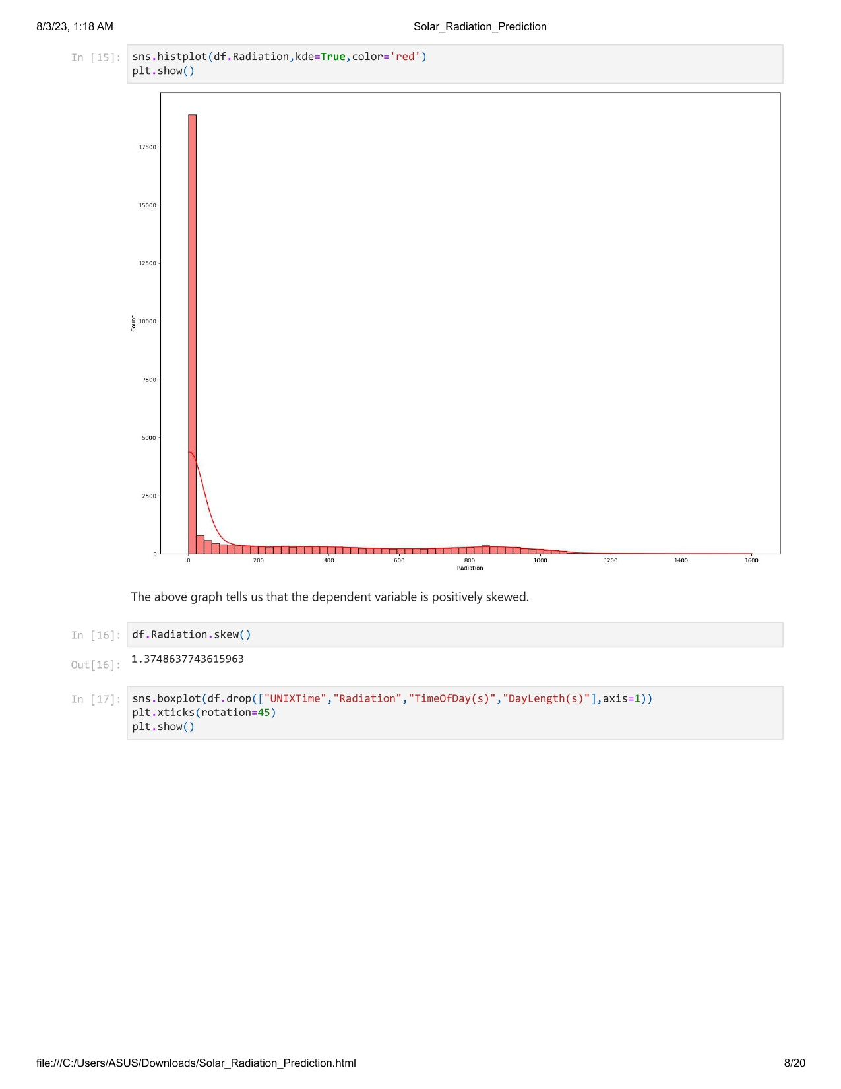

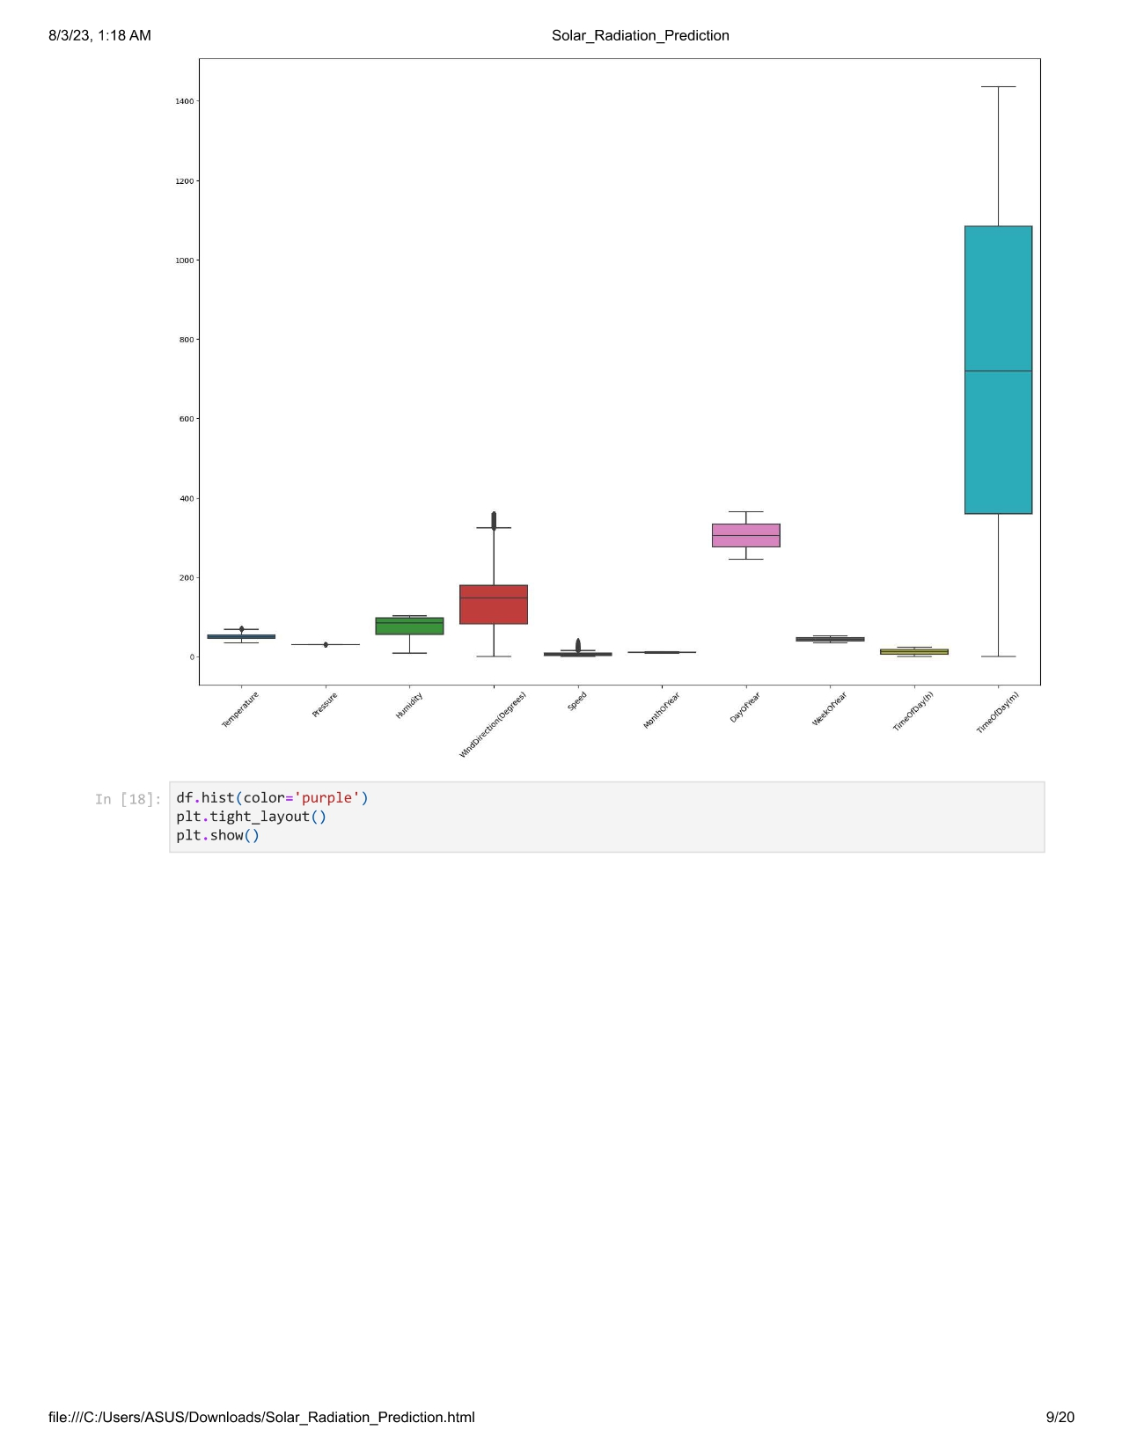

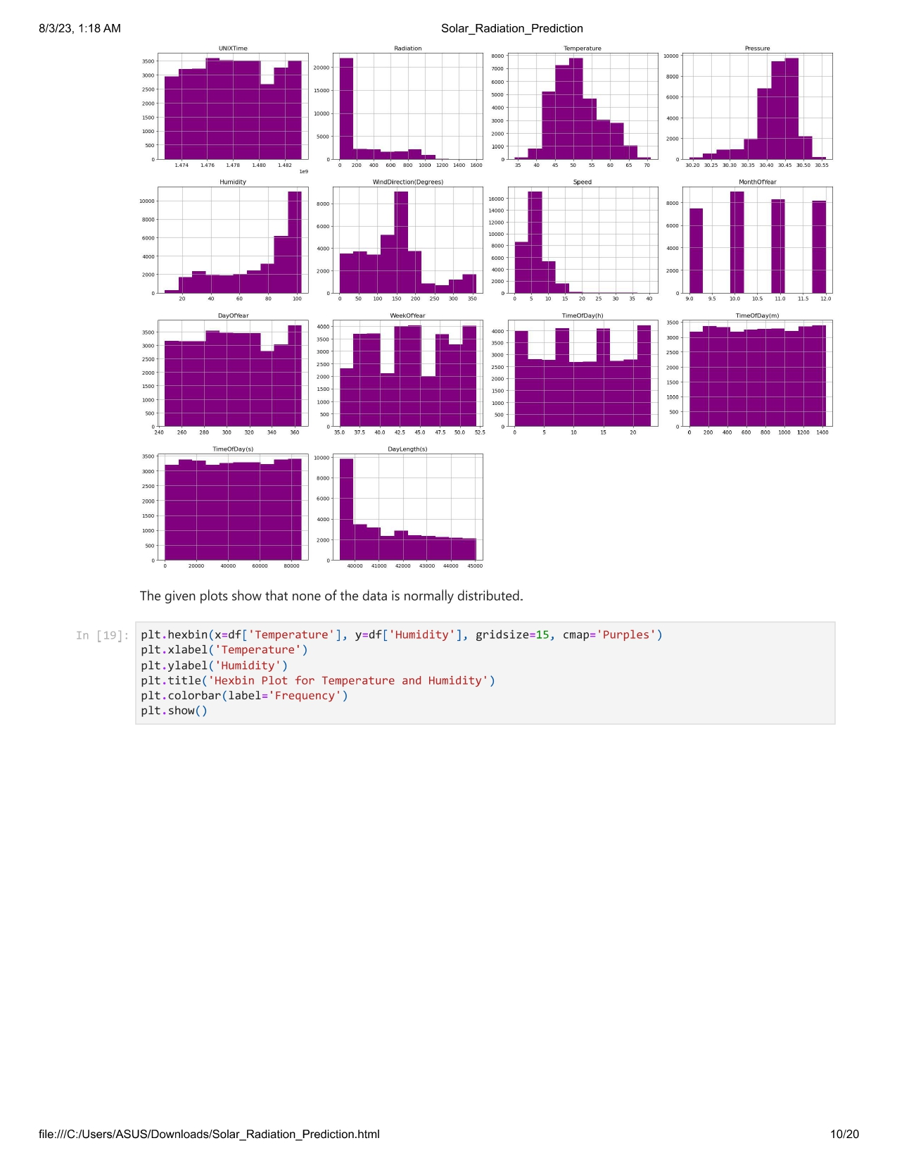

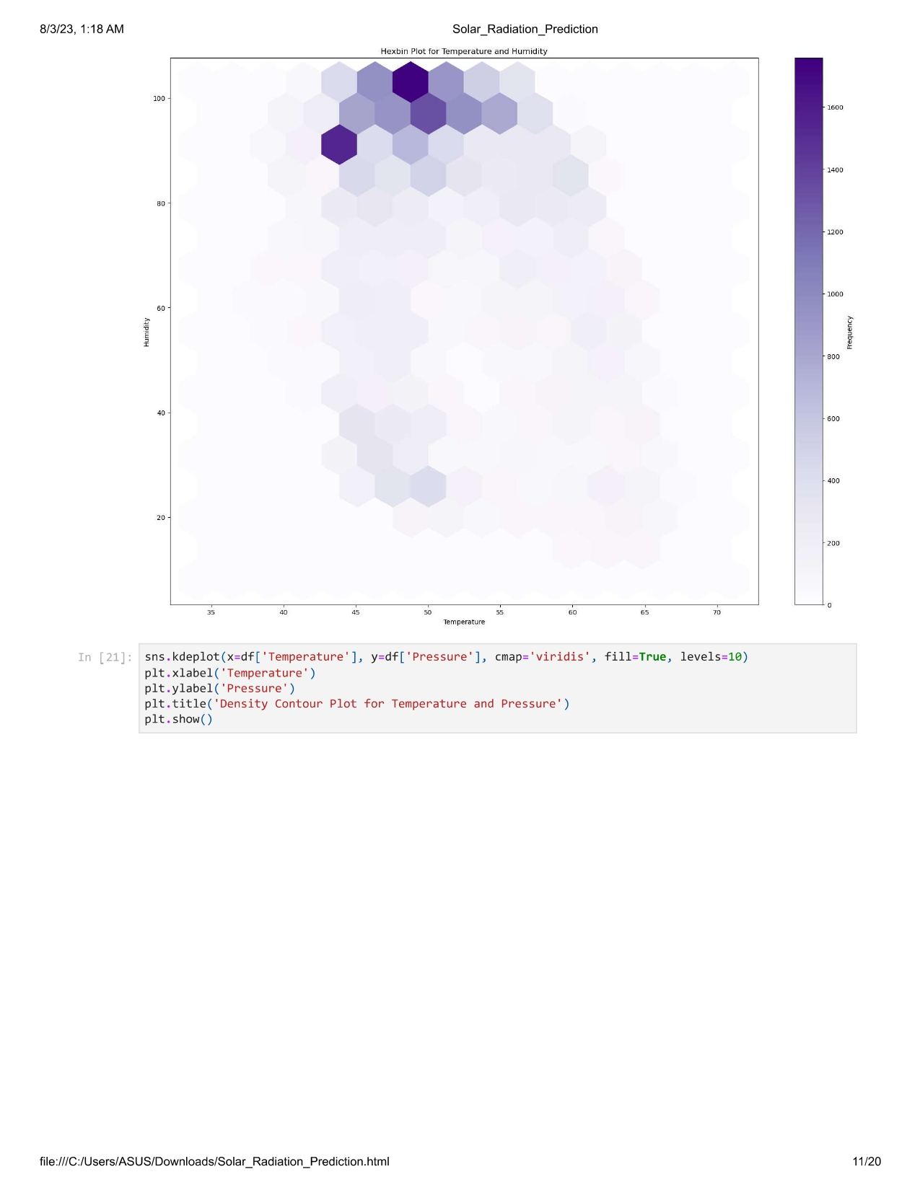

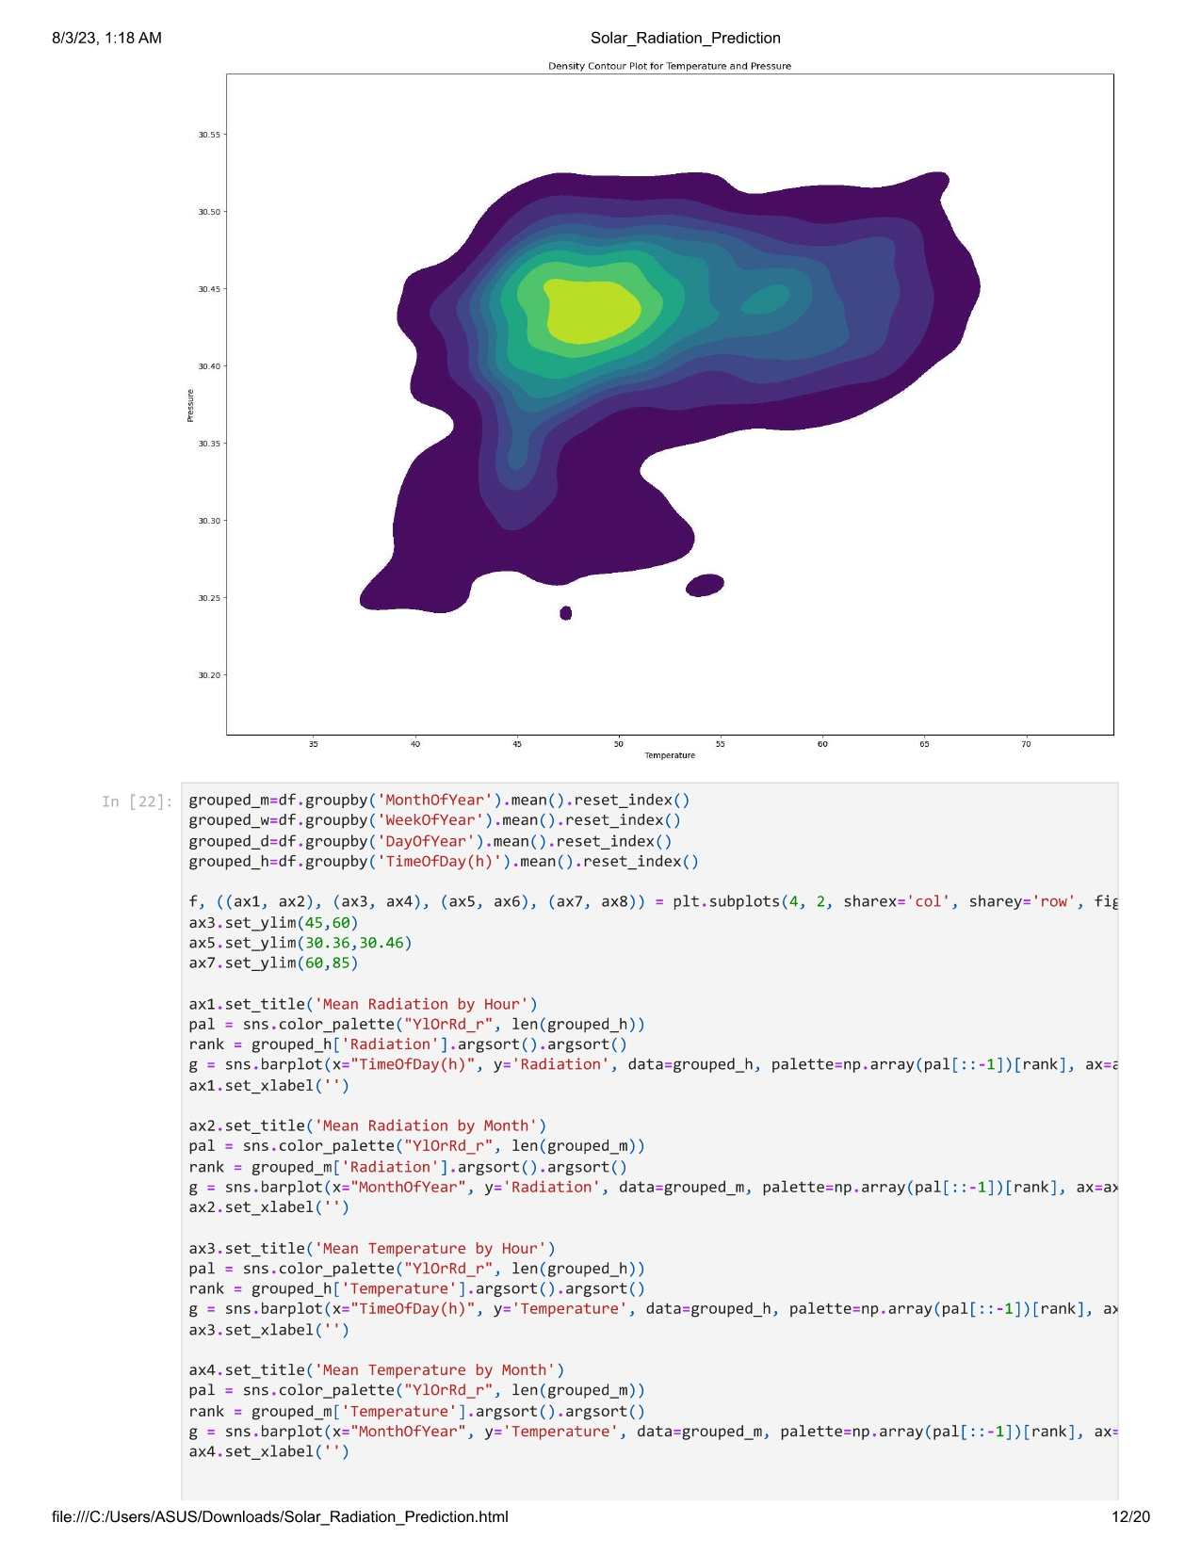

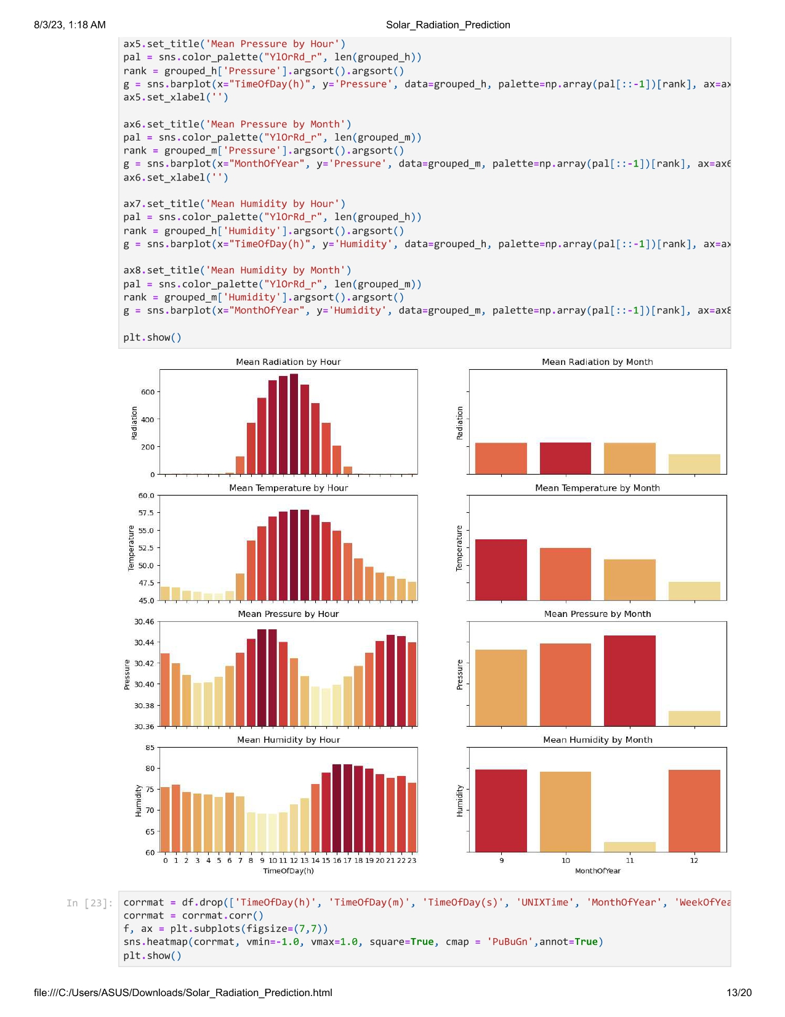

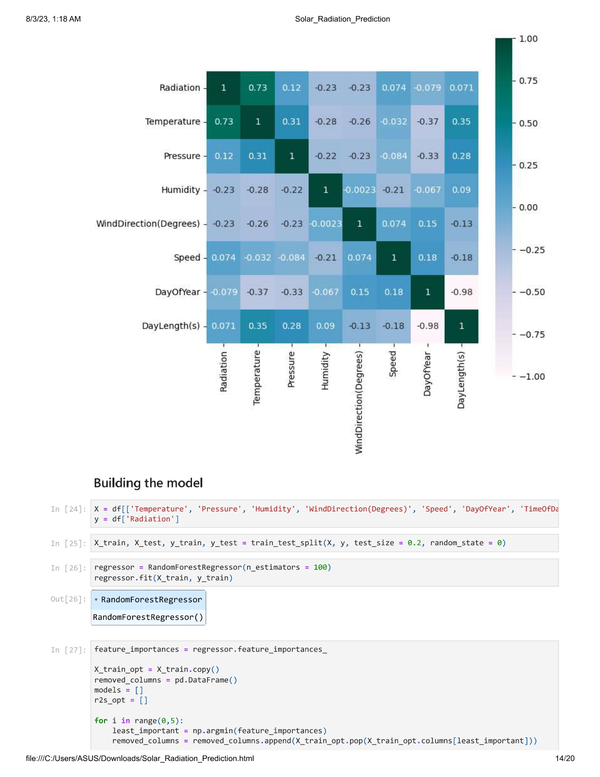

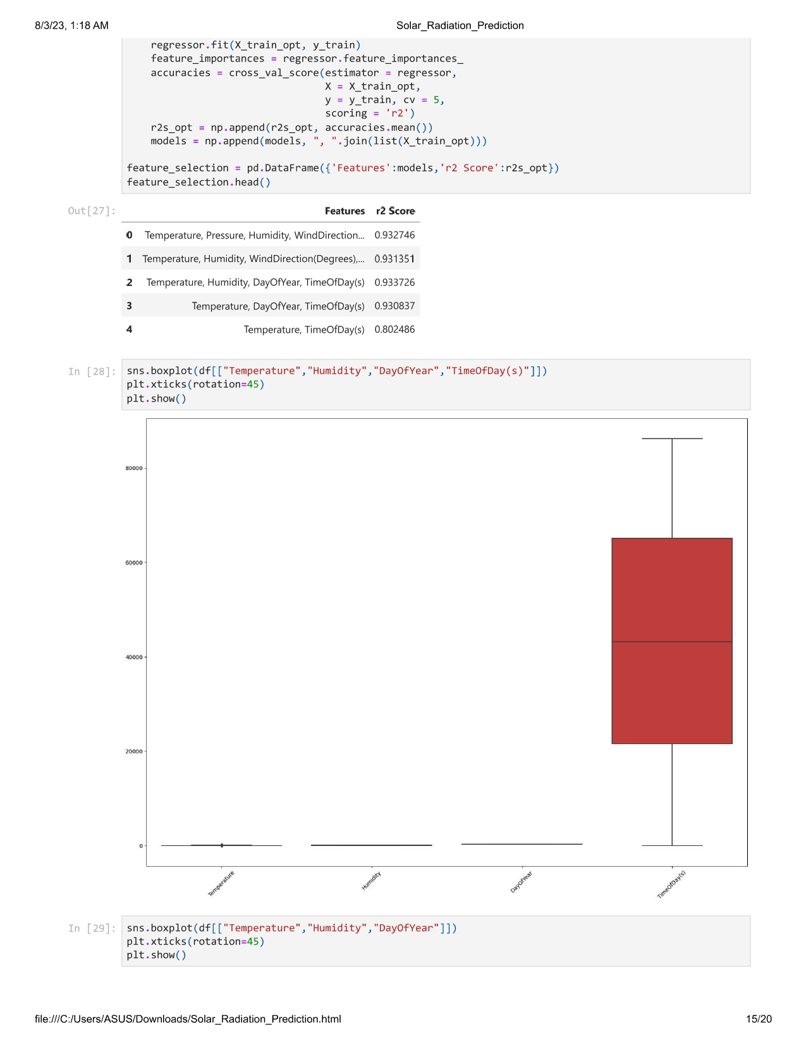

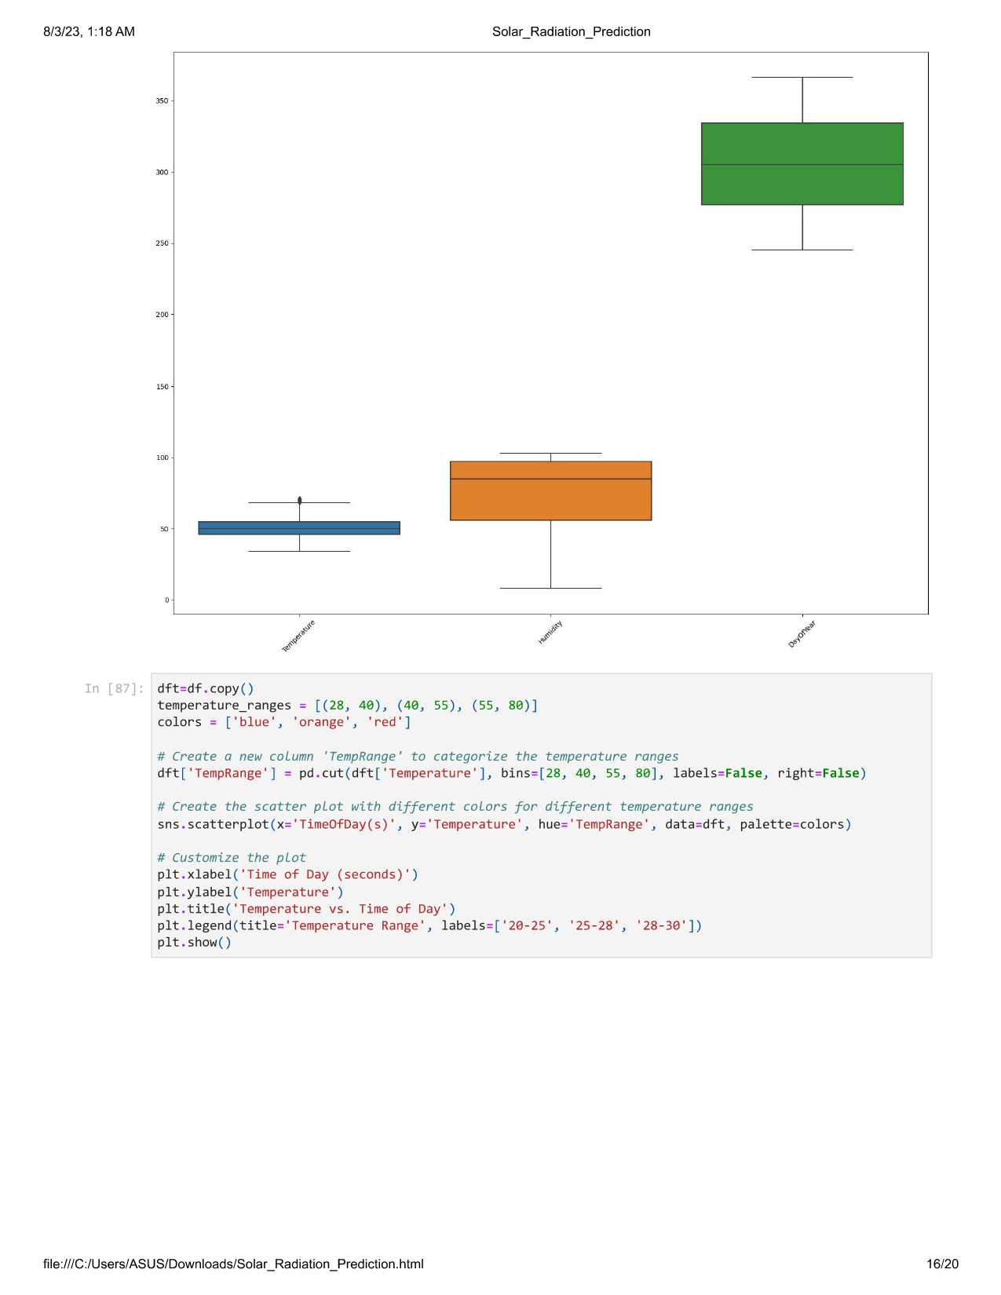

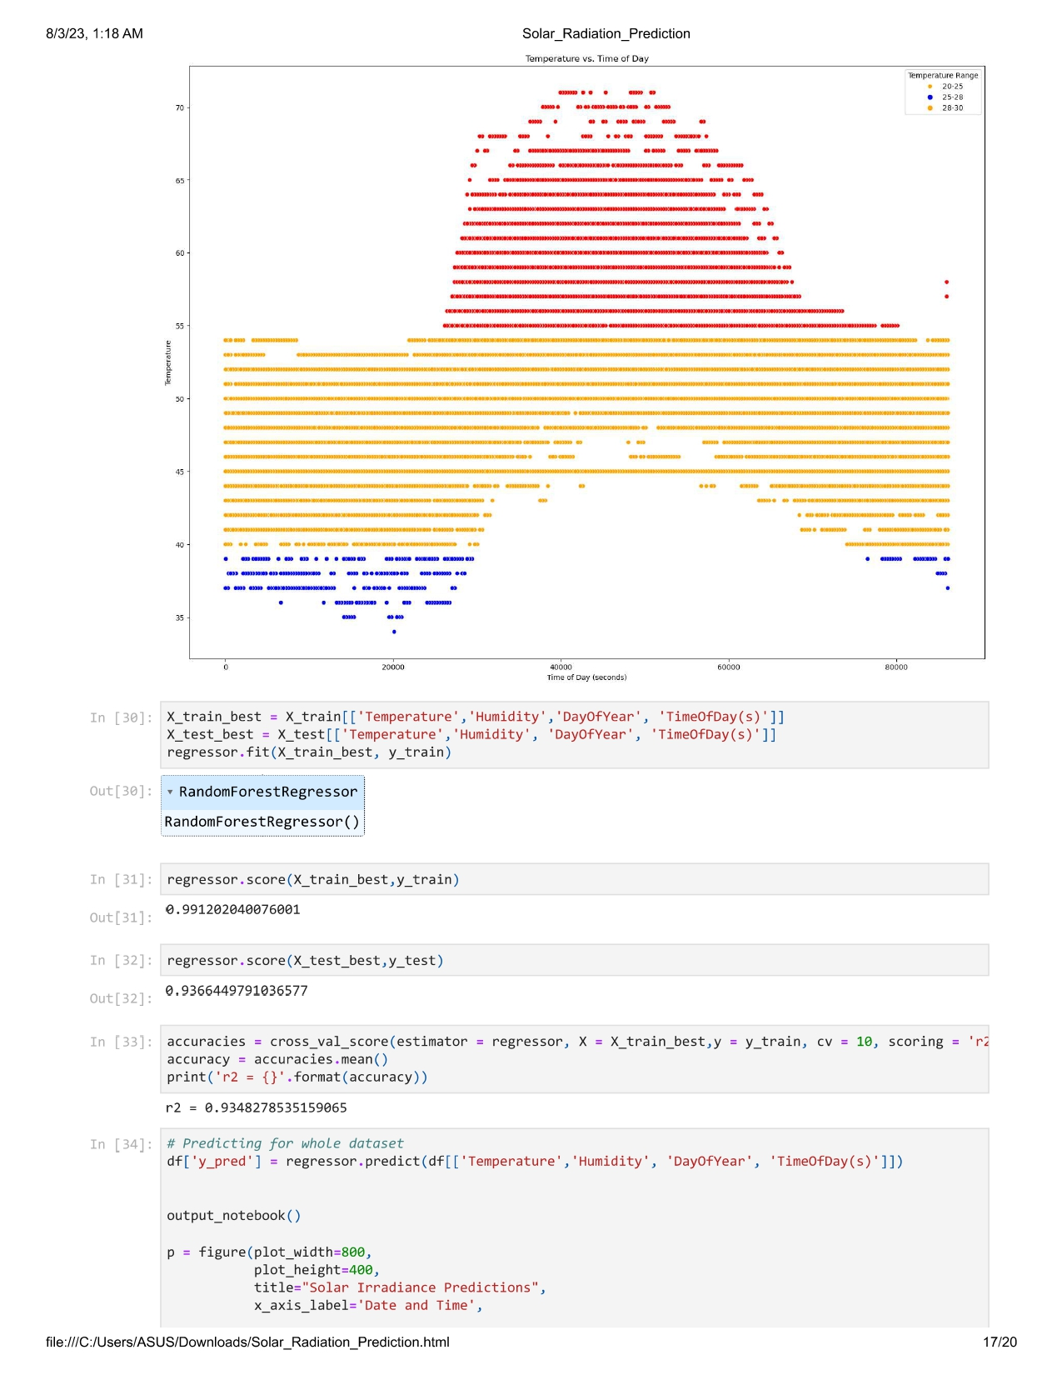

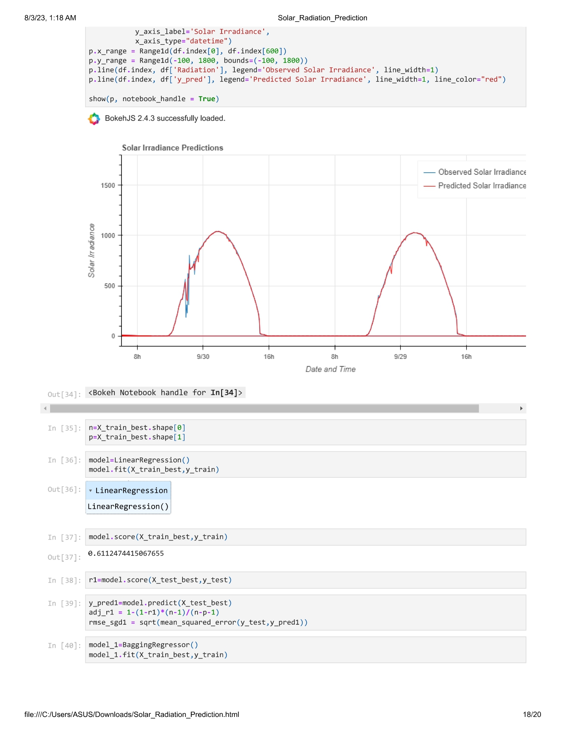

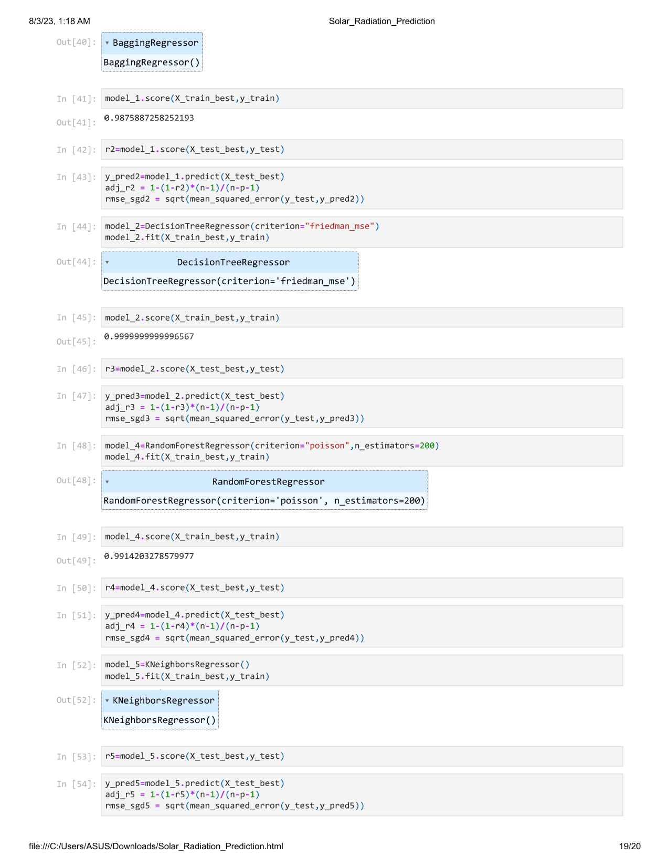

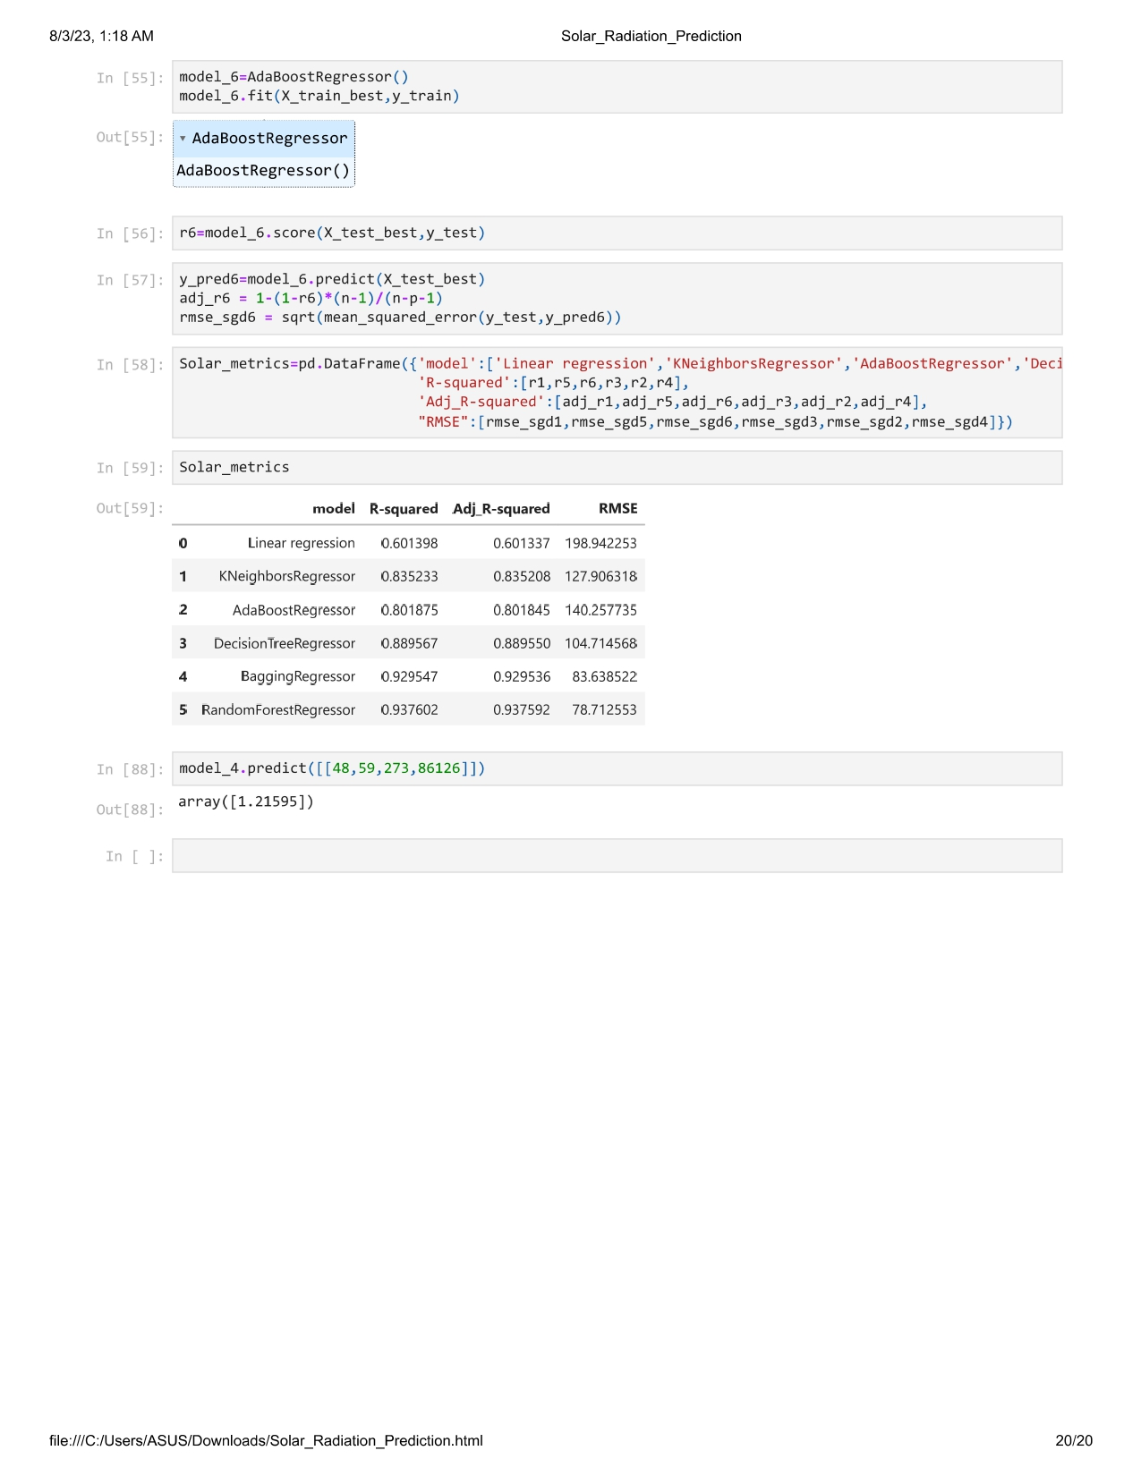

**CHAPTER 7**

**Results**

**The experimental results will include:**

**Data distribution plots and exploratory data analysis.**

**Comparative analysis of the performance of Random Forest, Linear Regression, and Bagging .**

**Evaluation metrics for each model, including RMSE, R2 and Adjusted R2 score.**

**Advantages & Disadvantages:**

**Advantages:**

**Accurate prediction of solar radiation levels for effective energy planning.**

**Optimization of solar energy utilization and grid management.**

**Contribution to sustainable energy practices and environmental conservation.**

**Disadvantages:**

**Dependency on the availability and quality of historical solar radiation data.**

**Computational complexity and time required for model training with large datasets.**

**Applications:**

**The proposed predictive model for solar radiation has various applications, including:**

**Solar energy planning and infrastructure development.**

**Energy generation forecasting for power grid management.**

**Renewable energy integration and grid stability.**

**Conclusion:**

**In conclusion, this project aims to develop an accurate predictive model for solar radiation estimation using machine learning algorithms. By analyzing historical solar radiation data and environmental parameters, we seek to provide valuable insights for renewable energy planning and grid management. The selected model will contribute to sustainable energy practices and foster the adoption of solar energy for a greener future.**

**Future Scope:**

**Future enhancements for this project include:**

**Incorporating real-time weather data for improved solar radiation predictions.**

**Expanding the model to cover a wider geographical area and multiple solar measurement stations.**

**Integrating the predictive model into solar energy management systems for real-world applications.**

**CHAPTER 8**

**CONCLUSION**

**In conclusion, our project successfully developed a predictive model for solar radiation estimation using machine learning algorithms. By analyzing historical solar radiation data and relevant environmental parameters, we created accurate predictions of solar radiation levels. Among the tested algorithms, Bagging (Random Forest) outperformed others, ensuring reliable predictions for solar energy planning and utilization.**

**The project's insights benefit businesses, policymakers, and energy planners, enabling optimized solar panel installations, improved grid management, and enhanced renewable energy integration. With data-driven decisions, businesses can enhance marketing strategies, product offerings, and customer engagement, leading to improved conversion rates and satisfaction.**

**Our project contributes to a greener and more sustainable energy future, leveraging the power of machine learning for renewable energy applications. The developed predictive model serves as a valuable tool for solar energy planning, paving the way for further advancements in renewable energy solutions.**